+1.0VALW, SoC ke "Always-On Power Management Domain" ko chalati hai.
3VALW / 5VALW ke baad 1.0VALW kyu aati hai? Ye kis liye hai?
Pehle SoC ko samajhiye
SoC ke andar sirf CPU nahi hota.
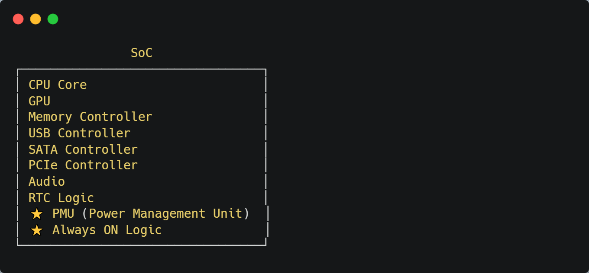
Ye Always ON Logic kis se chalta hai?
👉 +1.0VALW se
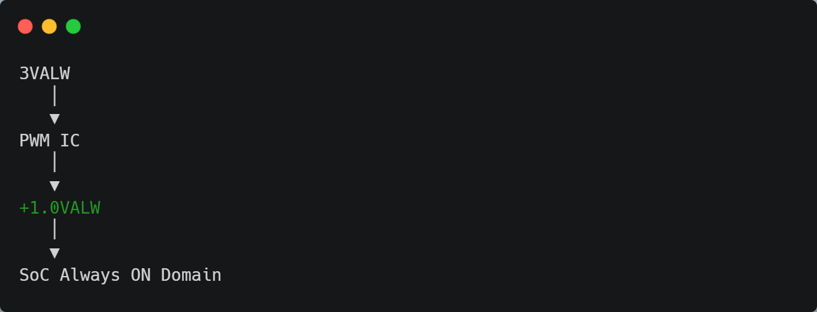

Iska kaam kya hai?
Ye CPU chalane ke liye nahi hai.
Ye chalata hai:
✅ PMU
✅ RTC Interface
✅ Power Button Detection Logic
✅ Wake-up Logic
✅ Sleep Logic
✅ Internal Reset Logic

Real Sequence
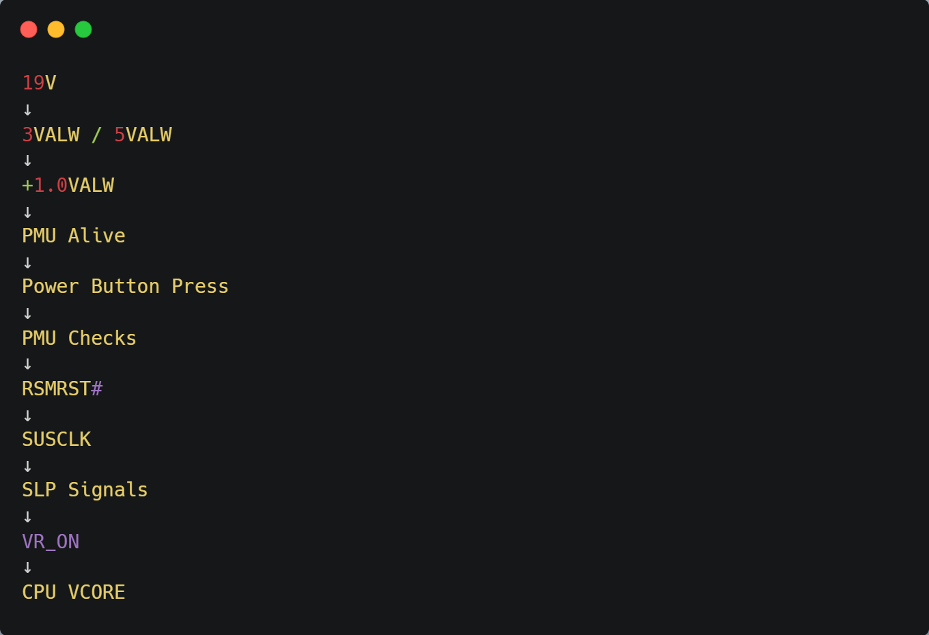

Kya +1.0VALW har board me hoti hai?
❌ Nahi.
Naam change ho sakta hai.
Example

+1.0VALW
+1.05VALW
VCCPRIM_CORE
VCCPRIM
VCCRTC_CORE
VCCPRIM_ALWAYS

Kaam same hota hai.

CPU Core ko chalane wali supply VCORE hoti hai, jo VR_ON ke baad VRM Controller generate karta hai.
Motherboard engineers voltages ko Power Domains me divide karte hain:
- RTC Domain (RTC Battery se powered)
- Always-On Domain (+3VALW, +5VALW, +1.0VALW)
- Suspend Domain (S3/S4 rails)
- Main Domain (CPU VCORE, GPU VCORE, DDR)

